**Experiment No. – 2.3**

**Student Name: Vivek UID:**

**Branch: CSE Section/Group:**

**Semester: 3rd Date of Performance: 13.09.2022 Subject Name: Object Oriented Programming Subject Code: 21CSH-218**

**Using Java**

**Aim of the practical:** You are given an interface Advanced Arithmetic which contains a method signature int divisor_sum(int n). You need to write a class called MyCalculator which implements the interface. divisorSum function just takes an integer as input and return the sum of all its divisors. Your class shouldn't be public.

**Objective: To study how to implement interface in java. Program Code:**

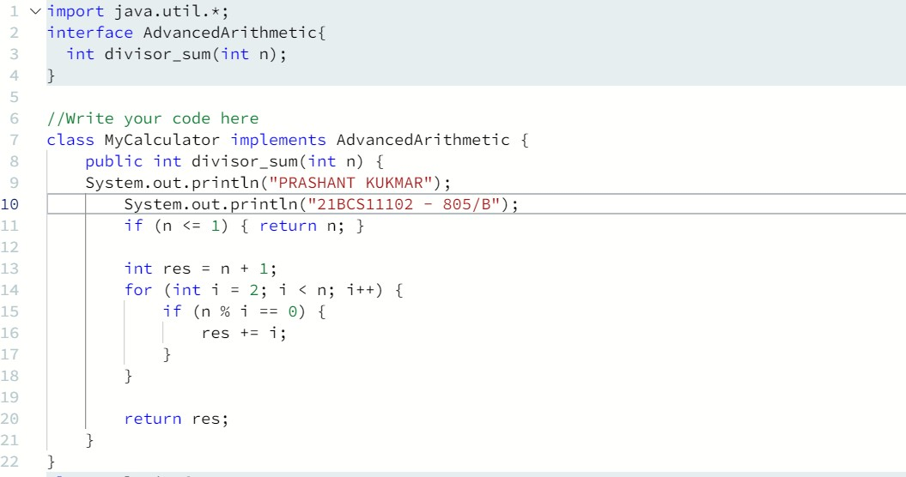

# DEPARTMENT OF

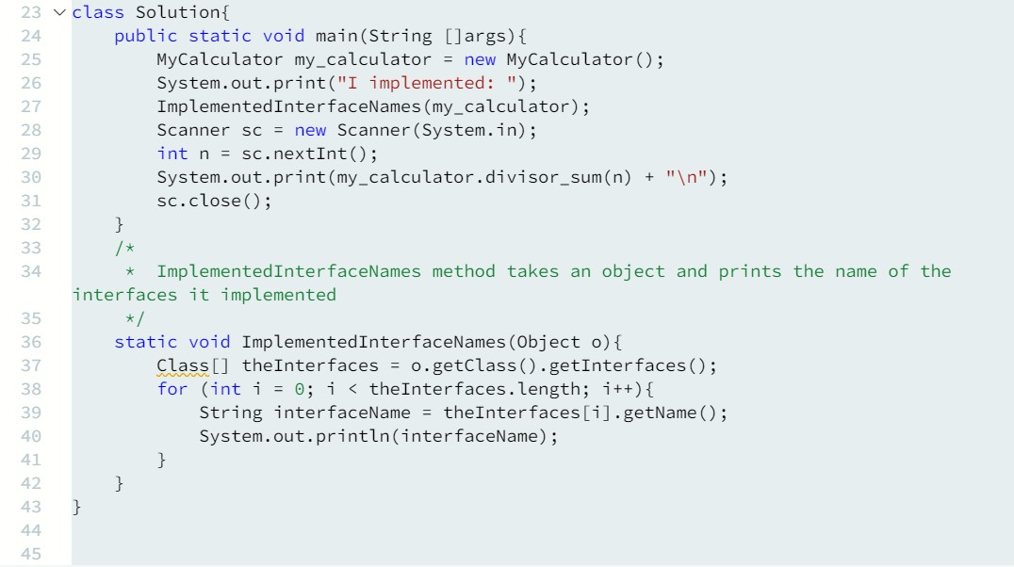COMPUTER SCIENCE & ENGINEERING

**Testcase:**

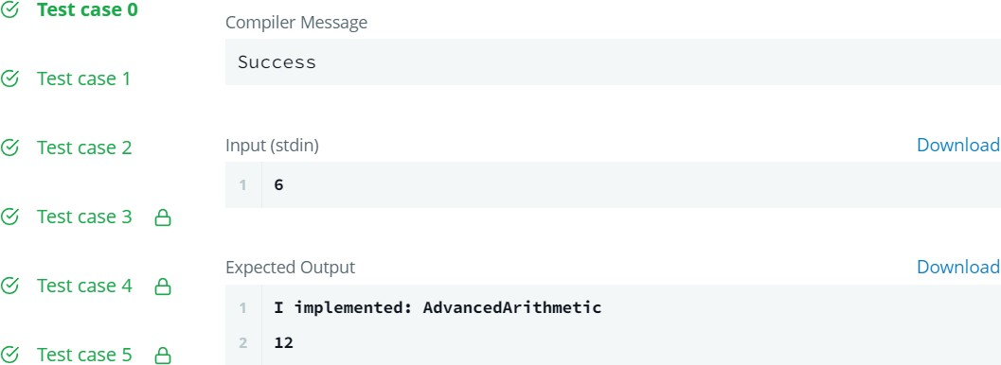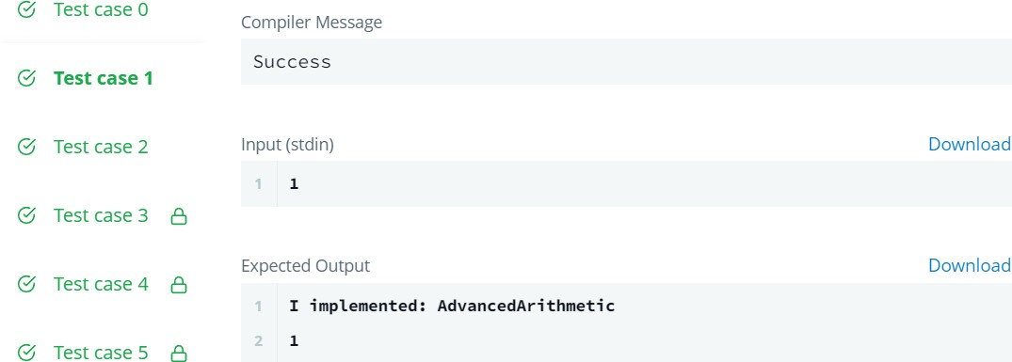

# DEPARTMENT OF



COMPUTER SCIENCE & ENGINEERING

